**Assignment4**

**Class&Objects**

**Q1.RoomVolumeCalculation**

**Design aclassnamed Roomwiththreedatamembers: height,width, and breadth.Include amethodvolume()tocomputeandreturnthevolumeoftheroom.Createaseparateclass RoomDemo that creates instances of the Room class and displays the volume for each instance.**

**Ans:**

**Input:**

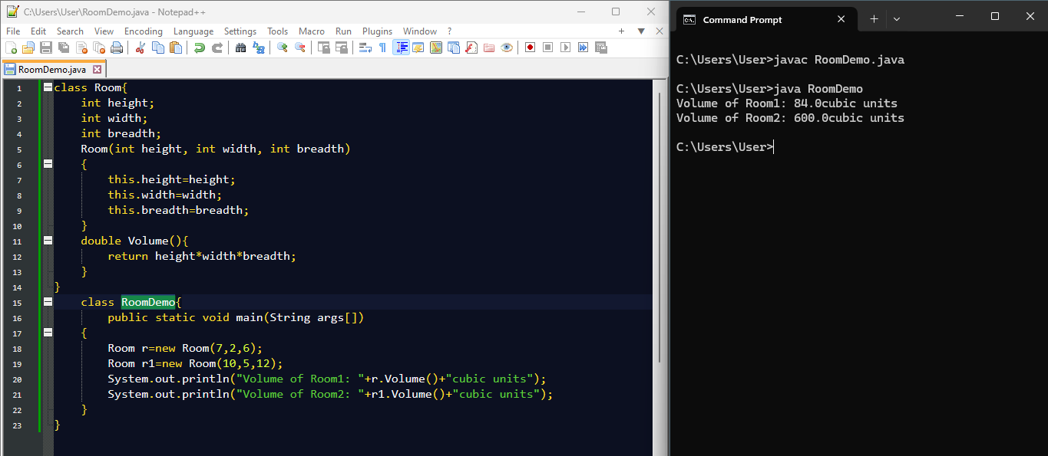

**Q2.StudentMarksandAverage**

**CreateaclassStudentwiththefollowingmembers:**

* **Nameof thestudent**
* **Marksinthreesubjects**
* **Amethodtoassigninitialvalues**
* **Amethodtocomputethetotalandaveragemarks**
* **Amethodtodisplaythestudent’snameandtotalmarks**

**Writeamain()methodtodemonstratethefunctionalityoftheclass. Ans:**

**Input:**

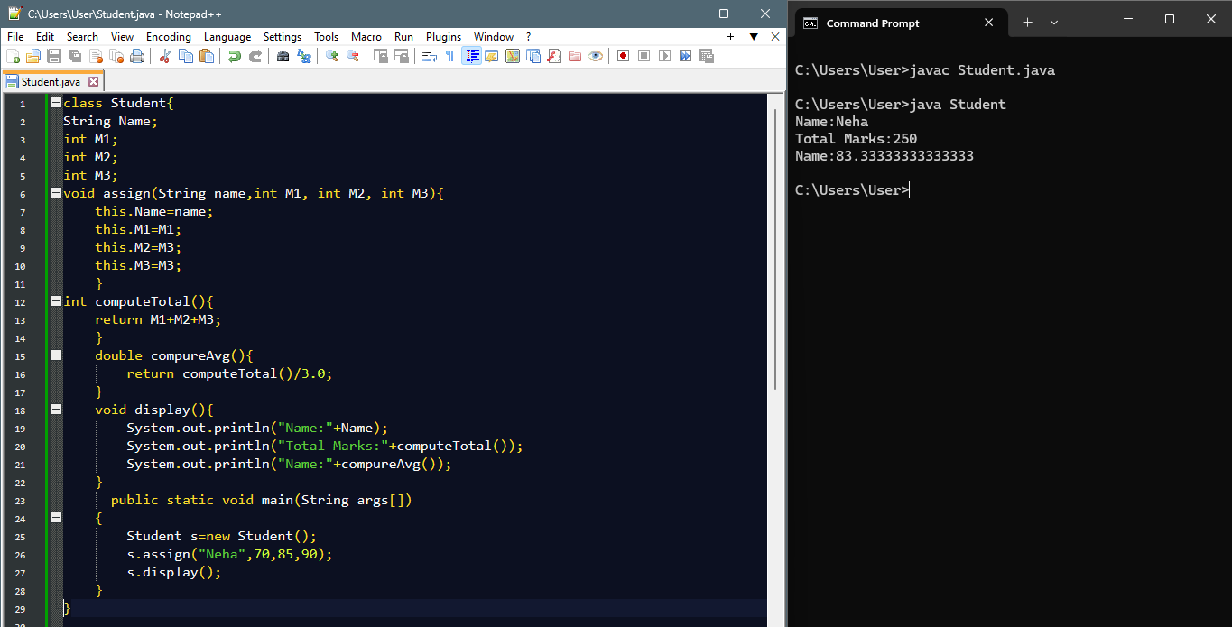

**Q3.BoxAreaand Volume**

**Write a class Box with three member variables: height, width, and breadth. Include appropriateconstructorstoinitializethesevariables.**

**Also,implement twomethods**

**getVolume()toreturnthevolumeofthe box**

* **getArea()toreturnthesurfaceareaofthebox**
* **CreatetwoinstancesoftheBoxclassanddisplaytheirvolumesandsurfaceareas. Ans:**

**Input:**

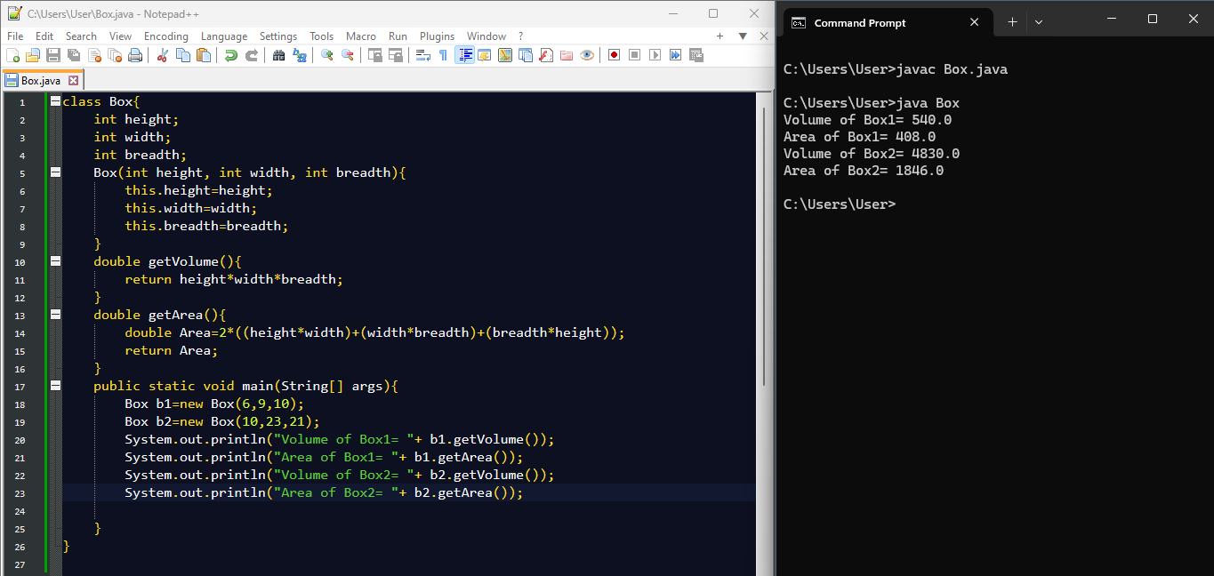

**Q4.ComplexNumberOperations**

**Createaclasstorepresentcomplexnumbers.Includethefollowingconstructors:**

1. **Adefaultconstructorthatsetsbothrealandimaginarypartsto0**
2. **Aconstructorthatinitializestherealpartonly**
3. **Aconstructorthatinitializesbothrealandimaginaryparts Also, write member functions to:**
   * **Addtwocomplexnumbers**
   * **Multiplytwocomplexnumbers In the main() method:**
   * **Createtwocomplexnumbers:3+2iand4 -2i**
   * **Displaytheirsumandproduct Ans:**

**Input:**

**Q5.BMI Calculator**

**DesignaJavaprogramtoimplementaBMI(BodyMassIndex)calculator.Theprogram should consist of a class named BMICalculator with the following specifications:**

**Class:BMICalculator Fields**

* + **height(double):Tostoretheheightofthepersoninmeters.**
  + **weight(double):Tostoretheweightofthepersoninkilograms. Constructors**
  + **Aparameterizedconstructortoinitializetheheightandweightfields. Methods**
  + **GetterandSettermethodsforbothheightandweight.**
  + **doublecalculateBMI():ThismethodcalculatesandreturnstheBMIusingtheformula: BMI=weight(height×height)\text{BMI} = \frac{\text{weight}}{(\text{height} \times**

**\text{height})}BMI=(height×height)weight**

**MainProgram:Writeaseparateclasscontainingthemain()methodto**

1. **CreateanobjectoftheBMICalculatorclass.**
2. **Prompttheusertoentertheirheightandweight.**
3. **Usesettermethodstoassignthesevaluestotheobject.**
4. **CallthecalculateBMI()methodtocomputetheBMI.**
5. **PrintthecalculatedBMItotheconsole. Ans:**

**Input:**

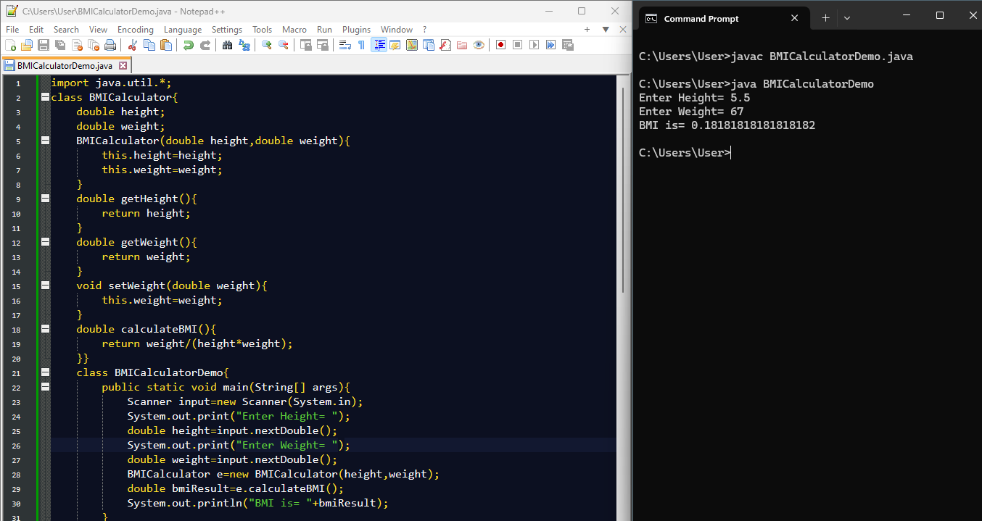

**Q6.ElectricityBillCalculation–JavaProgram**

**DesignaJavaprogramtocalculatetheelectricitybillforacustomerbasedonthenumber of units consumed. Implement a class named ElectricityBill with the following**

**specification**

**Class:ElectricityBill Instance Variables**

* **customerName(String):Nameofthecustomer**
* **unitsConsumed(double):Numberofelectricityunitsconsumed**
* **billAmount(double):Thecalculatedbillamount Constructor**
* **AparameterizedconstructortoinitializethecustomerNameandunitsConsumedfields. Method**
* **voidcalculateBillAmount():Thismethodcalculatestheelectricitybillamountbasedon the**

**followingtariffrules:**

* **First100units:Rs.5perunit**
* **Next200units(i.e.,101to300):Rs.7perunit**
* **Remainingunits(above300):Rs.10perunit Main Program**

**Inthemain() method:**

1. **CreateanobjectoftheElectricityBill class.**
2. **SetthecustomerNameandunitsConsumedvalues(canbetakenfromuserinputor hardcoded).**
3. **CallthecalculateBillAmount()methodtocomputethebill.**
4. **Displaythecustomer'sname,unitsconsumed,andfinalbillamount. Ans:**

**Input:**